**A PROJECT REPORT**

**ON**

**“Gaming Arena”**

**By**

Mayureshwar Shinde

**Abstract**

The project name is Gaming Arena. It is a collection of many different games.

The collection consists of two parts in which, one is Two player games. where you can earn money by winning. The second part consists of Single player games in which your opponent is (CPU)Computer itself. The Two player games part have games like Tic-Tac-Toe, Dream 11, etc. And the Single player game part have games like Guess the no, Stone paper Scissor, etc. The Final part consists of the Wallet balance which shows the amount that you have after winning or losing the game.

This project is the integration of many small games also showcasing the idea behind the fantasy type games.

**Table of Contents**

|  |  |
| --- | --- |
|  |  |
| **List of Figures ………………………………………………………………………...** | **1** |
| **1. Introduction ………………………………………………………………………..** | **2** |
| **1.1 General ……………………………………………………………………..….** | **2** |
| **1.2 Objective and problem statement ……………………………........................** | **3** |
| **2. Methodology ……………………………………………………………….............** | **6** |
| **2.1 Algorithmic details .…………………………………………………………...** | **6** |
| **2.2 Hardware and Software requirements……………………………..............** | **12** |
| **2.3 Design Details…………………………………………………………………** | **13** |
| **3. Implementation and Results …………………………………………………….** | **15** |
| **3.1. Implementation ....………………………………………………….................** | **15** |
| **3.2. Results ...………………………………………………………………............** | **16** |
| **4.Conclusion and Future Scope……………………………………………………..** | **18** |
| **5. References………………………………………………………………...........** | **19** |

# List of Figures

|  |  |  |
| --- | --- | --- |
| **Figure No.** | **Name** | **Page No.** |
| 1 | Main Menu | 6. |
| 2 | Multiplayer zone | 7. |
| 3 | Tic-Tac-Toe | 8. |
| 4 | Dream11 | 8. |
| 5 | Single Player zone | 9. |
| 6 | Guess no | 10. |
| 7 | Snake | 10. |
| 8 | Stone-Paper-Scissors | 10. |
| 9 | Wallet Gems Ballance | 11. |

**CHAPTER 1**

# INTRODUCTON

## 1.2 OBJECTIVE AND PROBLEM STATEMENT

* To Study the working of the virtual casino on the basis of real-life casino .
* To overcome with the idea of casino we made a Gaming Arena which is short derivate of casino .
* We already know that casino is worldwide famous for its Entertainment and Risk .
* In casino we invest our money  on the various games to play and win .  
  similarly ,

We Introduce here.  
GAMING ARENA :  
Which is little bit different form casino . In our arena , single player or the multiplayer can be played at a time according to their interests . And simultaneously user can check their wallet ,how much he/she can play  further  for more entertainment.  
  
Here in our Arena , you can Experience lot of fun .

**CHAPTER 2**

# METHODOLOGY

**Flowchart:-**

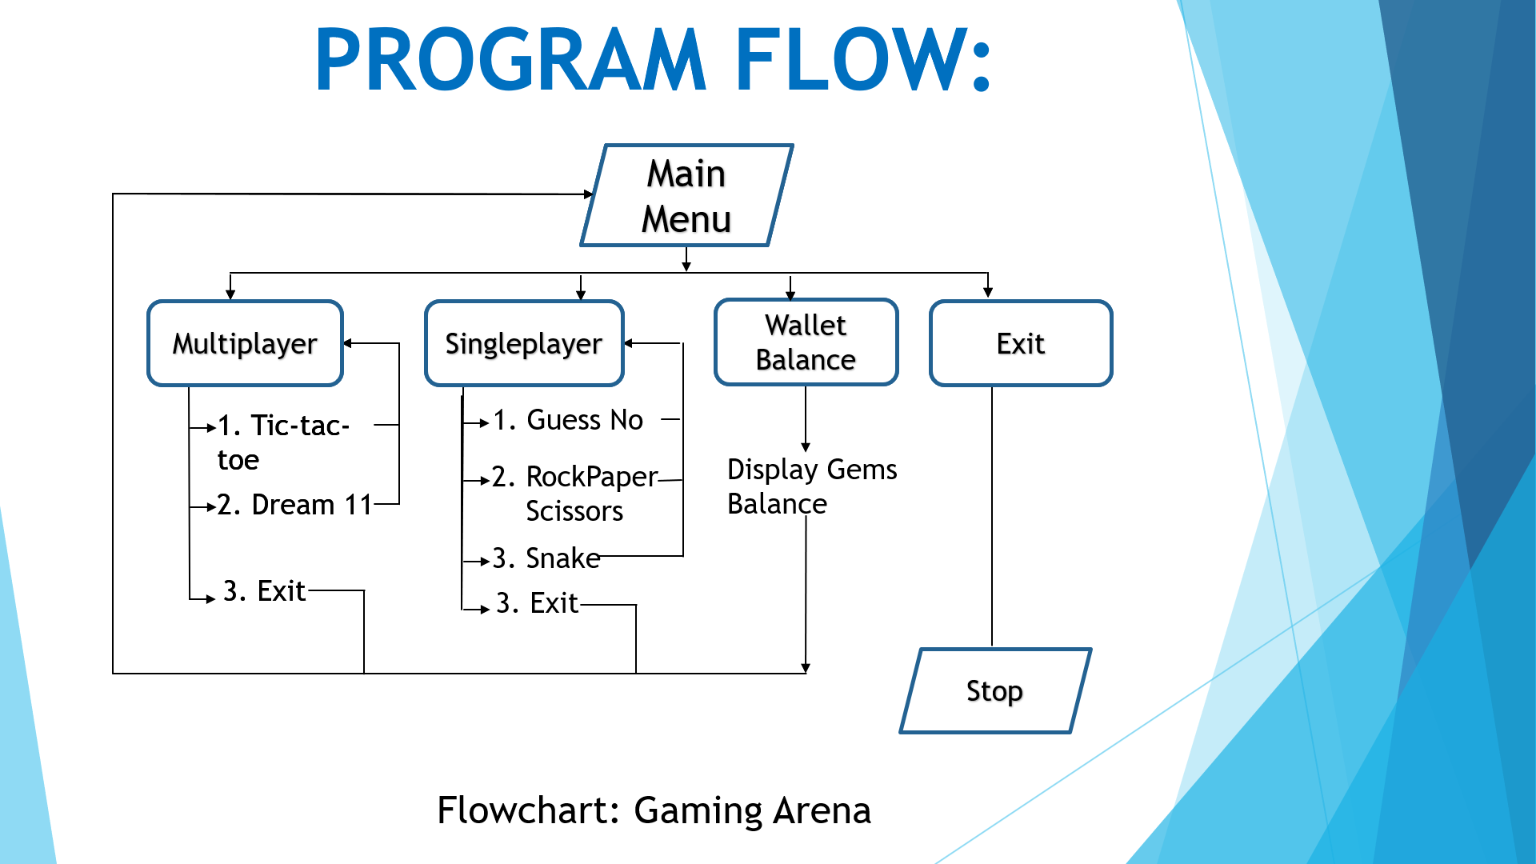

## 2.2 HARDWARE AND SOFTWARE REQUIREMENTS

**2.2.1 HARDWARE REQUIREMENTS**

1. RAM : 512 MB RAM
2. Hard Drive : 40 GB Hard Drive
3. Processor : Intel Core 2 Processor
4. camera module (Webcam)
5. Projector
6. Colour Markers
   * 1. **SOFTWARE REQUIREMENTS**

**2.3 DESIGN DETAILS:**

1. Vs code
2. MingW
3. C language
4. C++ language

The design is created in c and C++ with the help of various symbols and designing techniques.

The IDE or the editor used is Visual Studio code.

It has a retro type design with an attractive display and design technique by the use C/C++ only.

**CHAPTER 3**

# IMPLEMENTATION AND RESULTS

* 1. IMPLEMENATAION AND RESULTS**:**

*The Main page:

It consists of Single player zone, Play and win zone and the Gems balance zone.

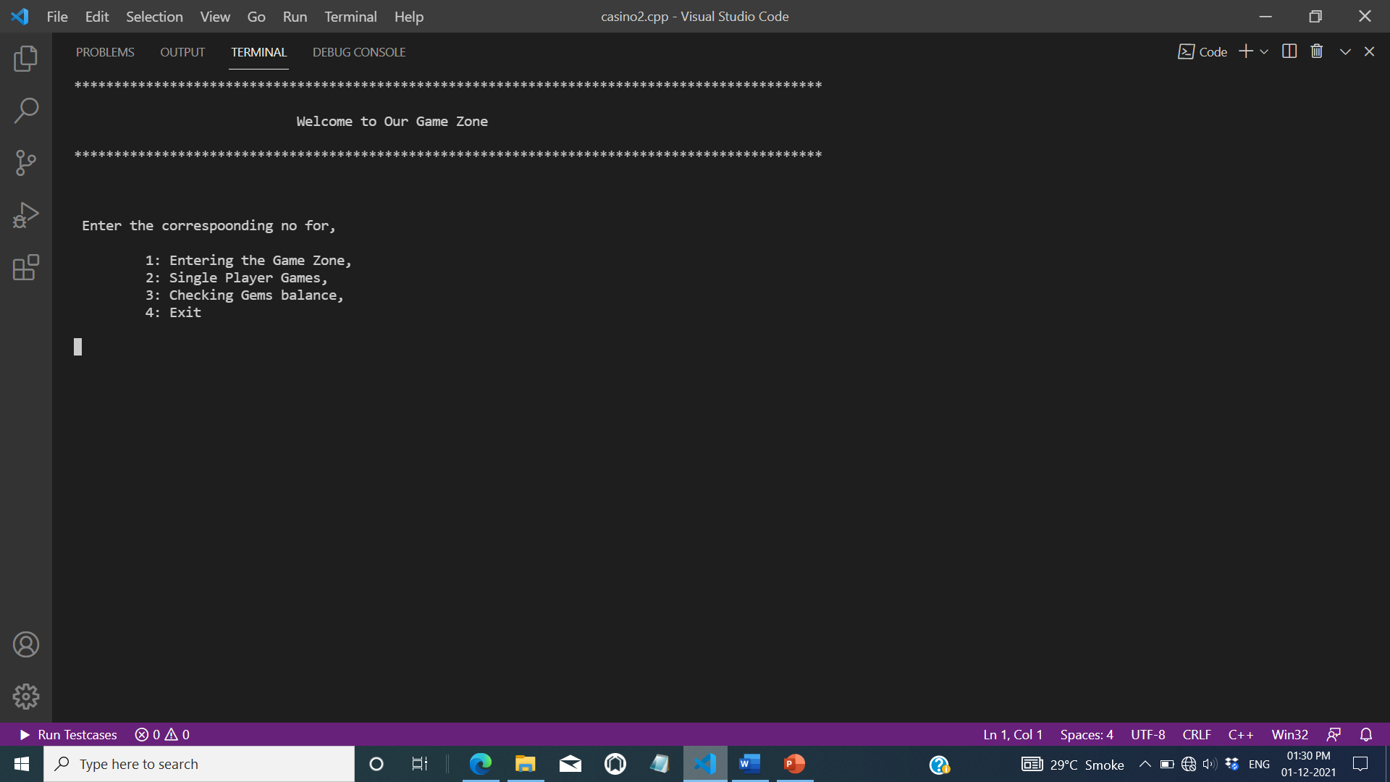

**1. The Game zone:**

In this section player bid an amount and gets double the Gems if he/she wins the game.

It consists of two games i.e. Tictactoe and Dream 11.

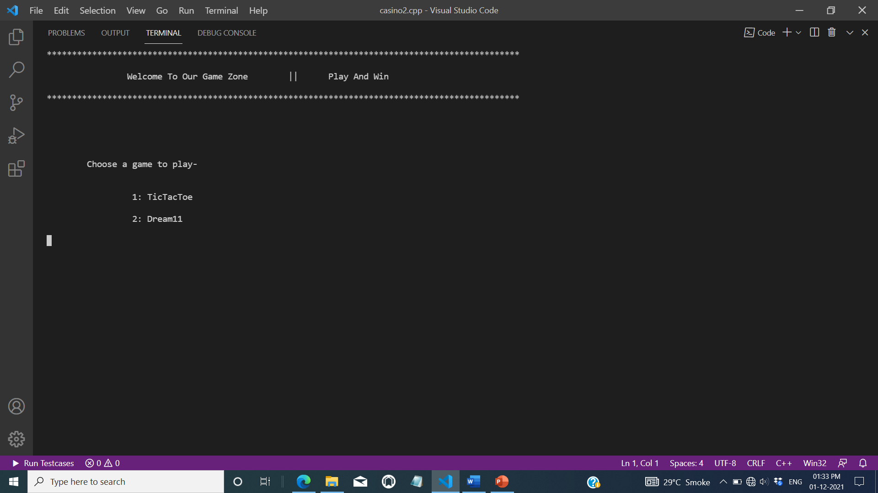

a) Tictactoe :

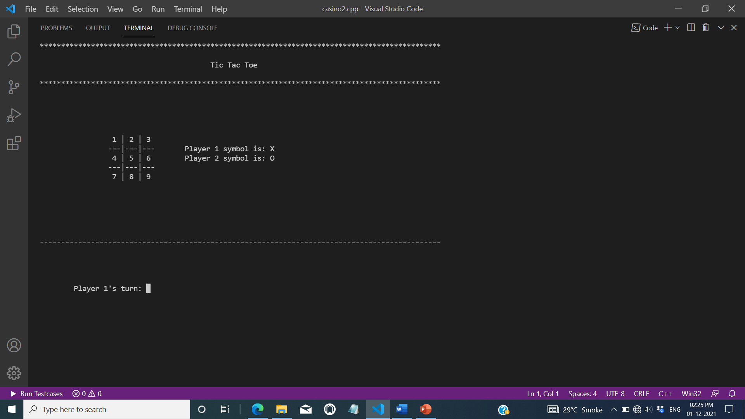

b) Dream 11 :

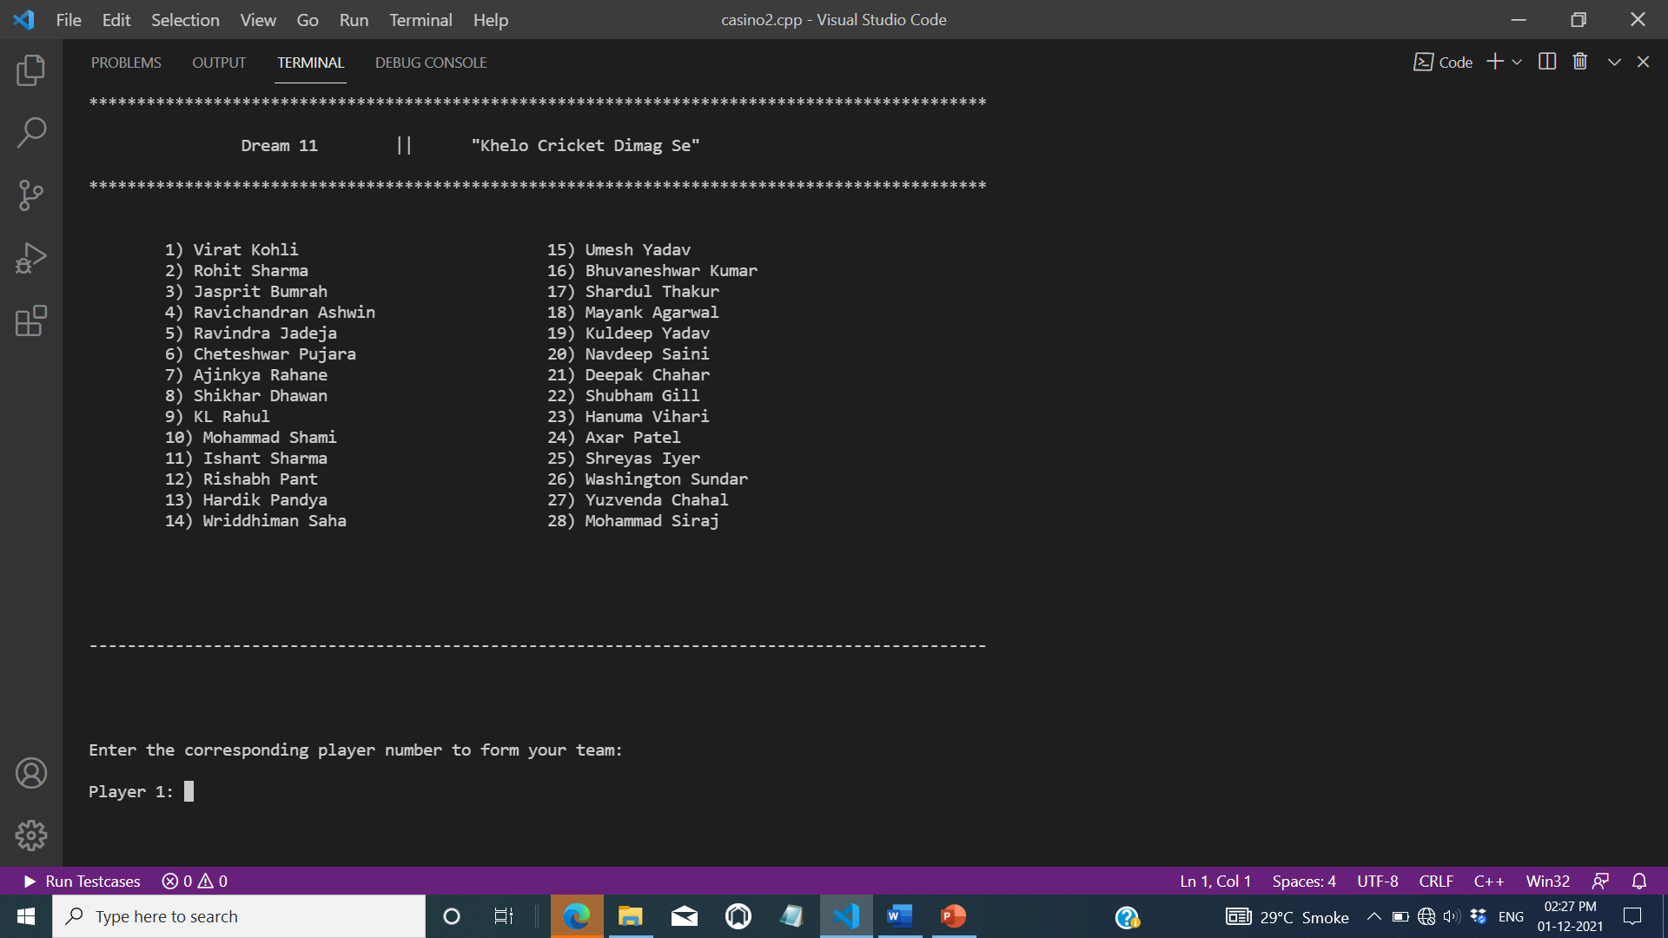

2. Single Player zone :

In this section player plays the game for fun.

He/she does not win after playing.

It consists of three games i.e. a) Guess no

b) Stone paper scissor and

c) Snake

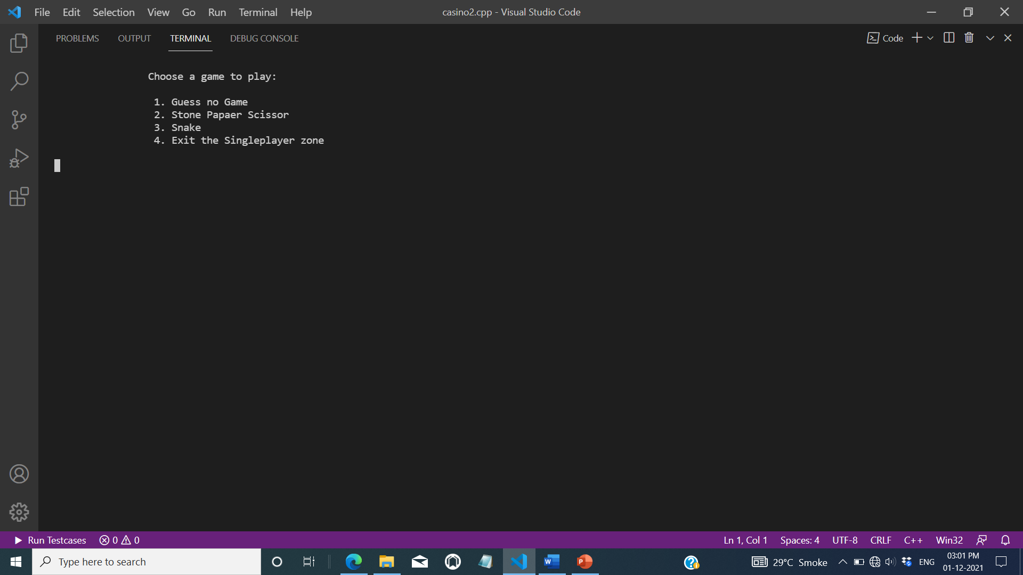

a) Guess no :

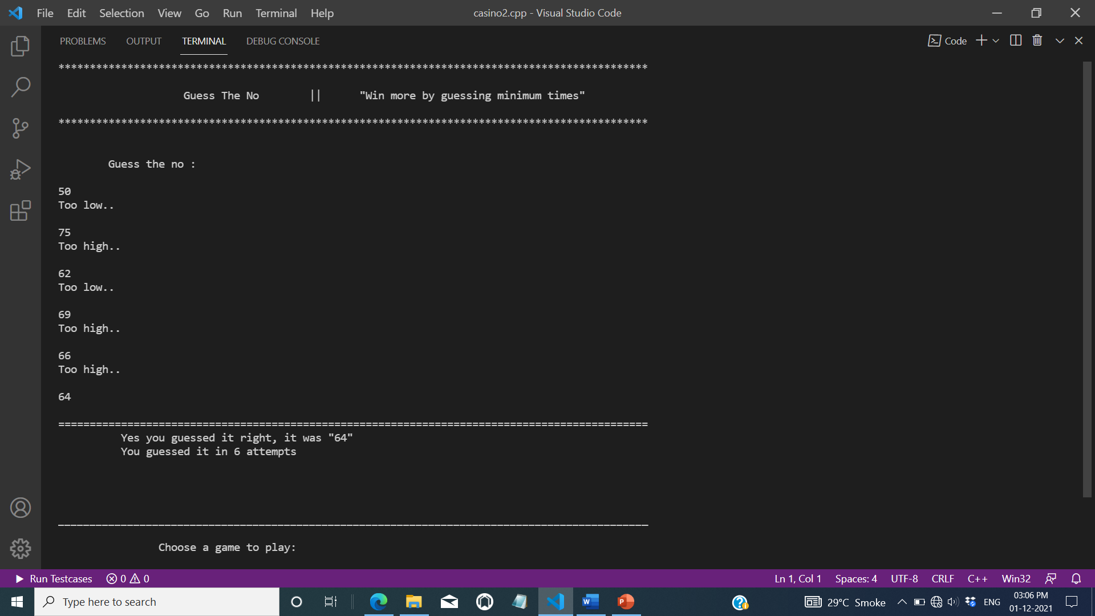

b) Stone paper scissor :

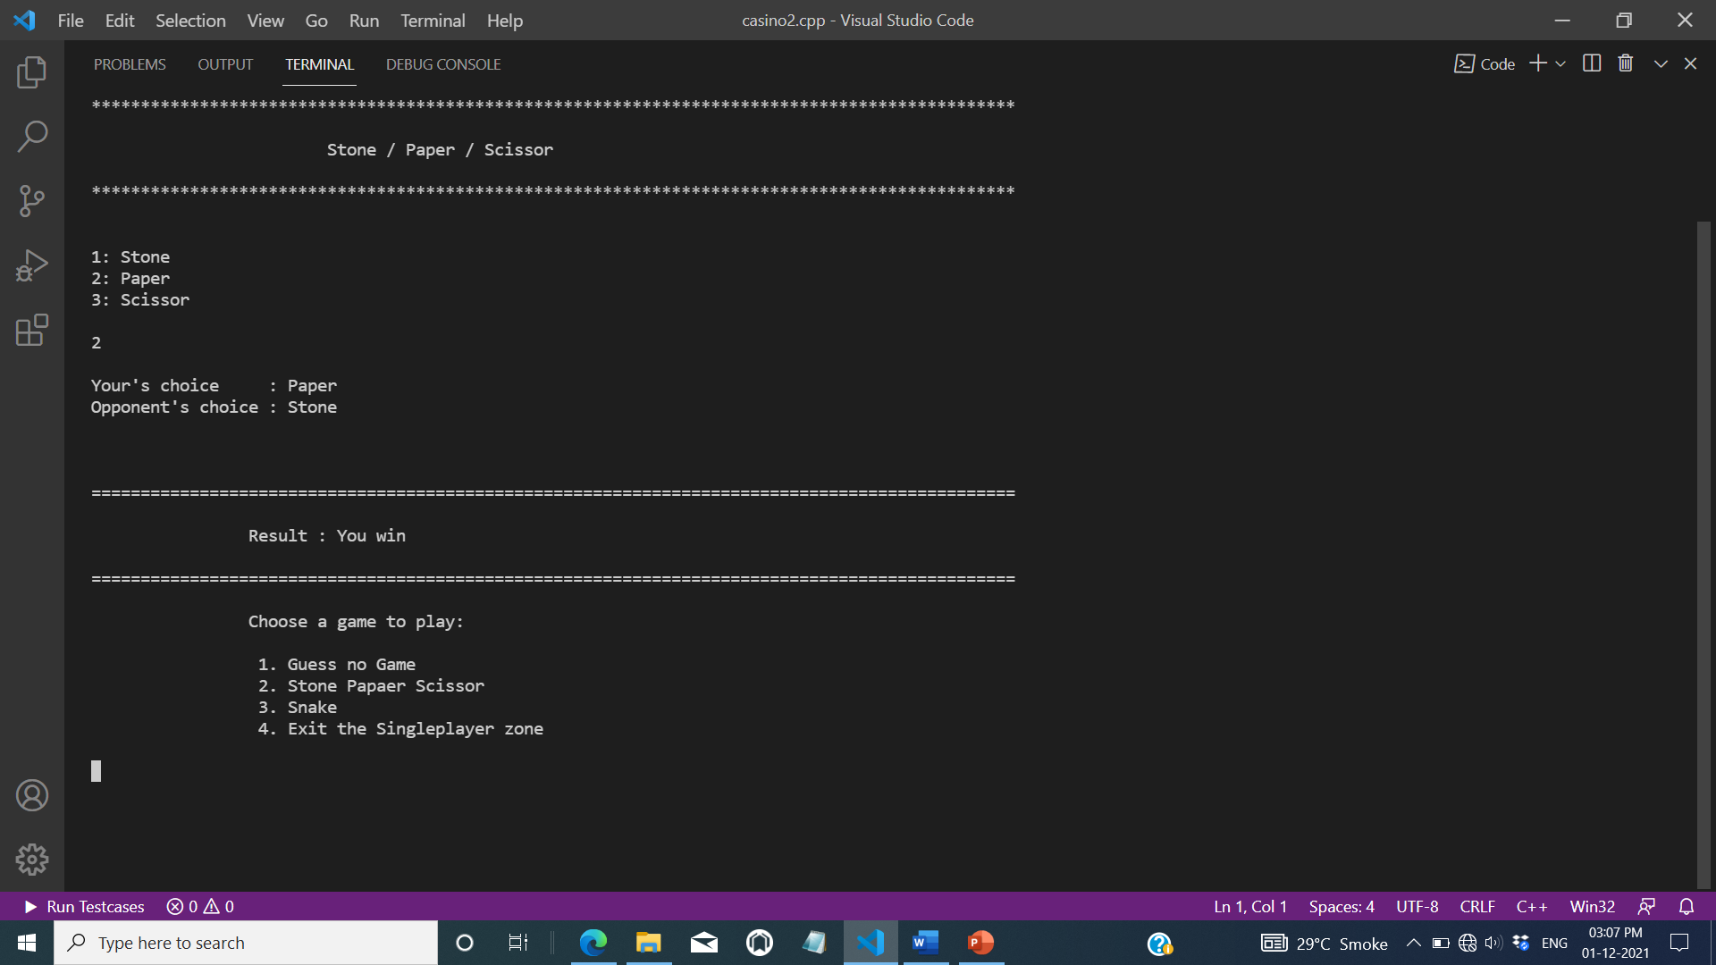

c) Snake :

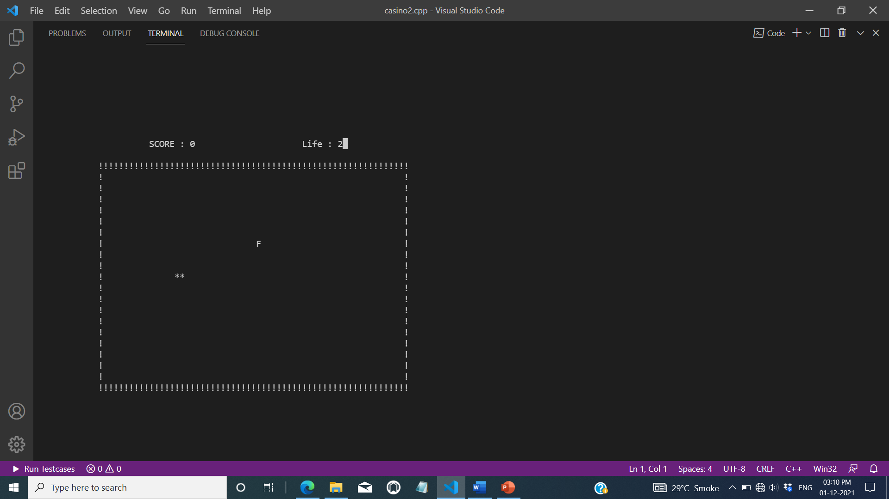

3. Gems Balance zone :

In this section players can see the number of Gems remaining in their account.

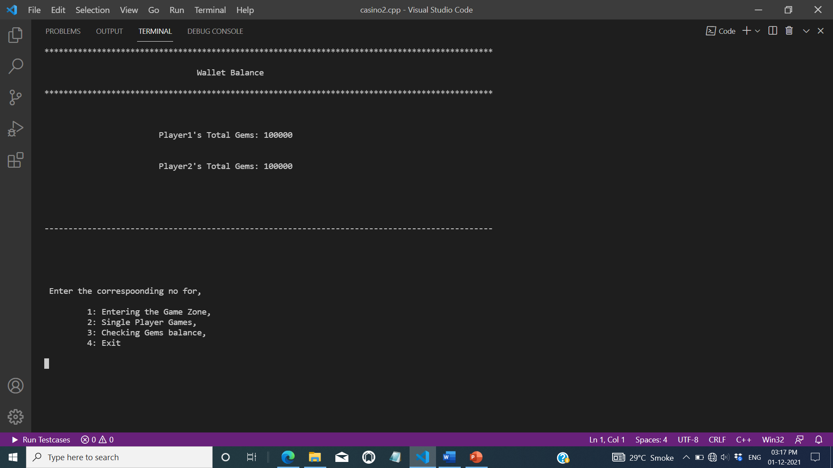

**CHAPTER 4**

# CONCLUSION AND FUTURE SCOPE

**CONCLUSION:**

The Gaming arena is designed to make the depiction of casino style games. It is a gaming app made for fun. In the Gaming Arena players come to enjoy and play games of their choice. This project is based on the fantasy type apps.

**Future Scope:**

➢ The Bank System can be added so that players can transfers their gems to their friends whenever they are in need.

➢ The database of the total players name and records of amount they have won and loose can be added.

➢ Later more games in the single-player and the multiplayer (Play and win section) also can be added.

➢ The project can be enhanced in future by adding graphics and animations to it further.